**Welcome Overla**y

Welcome text related to the competency’s associated goal

Generic bulleted list “about JUICE”

**Overview**

JUICE banner

Catchy and inviting context title using a gerund: *Facing grammar fearlessly!*   
 Immediately relatable context title, noun if possible: *Startup Magazine Editor-in-Chief*

Context description—two or three sentences and a call to action.

*Congratulations! You’ve just been hired as editor-in-chief for Community Living, an online magazine. The magazine has many devoted readers but there have been complaints about too many typos and grammatical errors. Your job is to fix the problems and make the magazine look as professional as possible*

Grouped  
 subcomps

Ungrouped subcomps,

Context picture

Mini-context group brief title  
Active skill name

Problem to solve 1 Problem to solve 2 etc.  
Brief skill name* Brief skill name*

*\*We have agreed that clarity is more important than matching forms for the brief skill names so we can and do have a mix of nouns and verbs.*

Skill name  
Friendly name

Grouped Subcomps--Math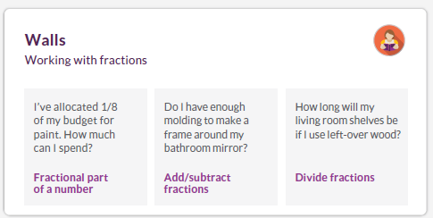



Grouped subcomps--Writing





What’s missing?

**Fix incomplete sentences**

Should it be one sentence or two? Can I use a semi-colon?

**Avoid run-on sentences** correctly

**Letters to the Editor**  
Sentences

Is it it’s or its?

Choose correct prepositions

How do I use the power of grammar to build a strong sentence?

**How sentences work**

**Word choice**

Ungrouped subcomps,

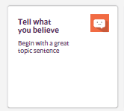

**Modulettes**

JUICE BANNER  
  
OVERVIEW BANNER

Friendly competency name  
 Friendly context name

Modulette title—Active (gerund) skill name* *Finding fractions of a number*

**Guided Practice Choose page**

Generic Choose intro text

**Context brief name Context brief name Context brief name**

Context question summary Context question summary Context question summary

Context photo

Context photo

Context photo

**Putting it all together**

Still in progress